Introduction (Jaderian)
This section should:
- introduce the broader data context (social, cultural, historical, institutional)
- introduce the data being analyzed (material context)
- introduce the overarching research questions
Social:
- Due to how prevalent car-centered commutes are in the United States, it is important to consider how much time drivers spend on roadways/ in cars on a day-to-day basis.
- The demographic of drivers is also important to contextualize:
  - Age Groups: There is a wide range of age groups that drive on our roadways everyday, so it is important to consider which age groups may or may not be getting more involved in car accidents. A variety of contexts can be inferred from this demographic, including:
    - The driving experience of an individual (whether or not someone has been driving more, driving less, or based on how long it’s been since they’ve acquired their driver’s license) and how it affects their driving patterns.
    - The attitudes of some of these drivers (recklessness, speediness, cautiousness, road rage, etc.)
- Group size is also important to consider, especially if we are looking at solo-traveling or carpooling, which ties into the social context of traveling/ commuting.
Cultural
- It is worth considering the times in which most people are on our roadways, as there are various reasons as to why there could be certain traffic conditions/ driving patterns.
  - Work/Commute Culture: Commuting is common in U.S. driving culture as people need to travel to get to their jobs, classes, and workplaces. This is where “rush hour” comes into play.
  - Major Holidays/ Leisure Outing: this is where more people are on the road, traveling to wherever they need to be to celebrate holidays or go on vacation, which impacts overall traffic and plays into the risk of car accidents.
  - Drunk Driving: nightlife and drinking culture is also important to consider as risky driving/ driving under the influence is shaped by these activities.
  - Distracted Driving: this could mean texting while driving and other bad habits that may affect the way people drive
  - Location-Based Driving: people drive differently in cities/ busier areas than in areas with not as much traffic
  - Rule Following: do people follow the rules of the road?
Historical
- Certain regions, historically, may or may not be prone to accidents for many reasons:
  - Some areas experience more traffic than others, making it more prone to accidents with a higher density of drivers on the roadways.
  - How infrastructure is built and how people interact with them over time also plays into how people drive. Some may be outdated, while some may be relatively new. Some may be lower in quality due to erosion or constant use, some not so much. Some may have more risks in terms of how they are built onto roadways, while some may be geared to prevent accidents and any other road delays.
  - The presence of construction and its duration at a given area.
Institutional
- Who regulates and maintains road infrastructures?
  - Thinking about who regulates certain roadways, whether that be private companies, agencies, or even governments (city, state, or national).
  - Filtering out where these accidents occur
- Who regulates traffic and enforces traffic rules?
  - This includes law enforcement (such as police, who are more hands-on, or even those who create road laws)
- Whoever issues drivers licenses (mainly states) since there are different state laws for driving.
- Car and health insurance companies of those involved in accidents.
Material
- The dataset was collected in real-time through the use of real time traffic APIs
  - The APIs broadcast traffic data captured through various methods such as US and state departments of transportation, law enforcement agencies, traffic cameras, and traffic sensors within the road networks.
- The creator of the dataset referenced the following two papers
- Moosavi, Sobhan, Mohammad Hossein Samavatian, Srinivasan Parthasarathy, and Rajiv Ramnath. “A Countrywide Traffic Accident Dataset.”, 2019.
- Moosavi, Sobhan, Mohammad Hossein Samavatian, Srinivasan Parthasarathy, Radu Teodorescu, and Rajiv Ramnath. "Accident Risk Prediction based on Heterogeneous Sparse Data: New Dataset and Insights." In proceedings of the 27th ACM SIGSPATIAL International Conference on Advances in Geographic Information Systems, ACM, 2019.
- Every accident in 49 out of the 50 states (excluding Hawaii) from February 2016-March 2023 is represented by the data
Research Questions:
Primary: What combination of weather conditions at certain traffic/road infrastructures increase the overall severity of a car accident in the state of California?
Secondary: Which road infrastructure is associated with high severity car accidents of the accidents that have been recorded?

Methods (Jaderian)
This section should discuss the methods you used to process the data and the models you chose. Specifically, you should discuss:
- How you cleaned / modified the original data and why.
In the original dataframe, there were missing/ NaN values that needed to be cleaned up in order to prevent errors in the future, especially when we are dealing with categorization and calculations. Any “string” based features that were NaNs were filled with a “Missing” string, and missing numerical values were filled in with zeroes.

- The “Weather_Condition” variable included all the types of weather conditions that were recorded at the time of the accident’s occurrence, and due to similar conditions, we decided to create subgroups that we could then categorize each condition into: “CLEAR”, “CLOUDY”, “RAIN”, “SNOW”, “LOW_VIS”, “DUST”, “HAIL”, and “WINDY.”
We had also separated the features in terms of categorical variables and quantitative variables so that they could be respectfully standard scaled or OneHotEncoded when making our column transformers and pipelines for logistic regression.
The variable “Severity,” which is a numerical value in which categorized the four different levels of car accident severity in terms of how much impact it had on overall traffic on a scale from 1-4, with 4 being the highest severity level. In order to prepare it for our logistic regression model, we turned this variable into a binary value in order to indicate a range from 1-2 being less severe and 3-4 being more severe.

- What features you considered for your analysis and why.
Our primary feature that we are basing our project on is the “Severity” of the accident. As mentioned above, this is given in a scale from 1 to 4, with 1 being the least severe (least amount of traffic impact) and 4 being the most severe (most amount of traffic impact). We then thought it best to turn this variable into a binary variable so that we can determine the lesser severe occurrences and the more severe occurrences.
To better answer our primary question, we then considered features that are associated with weather conditions, infrastructures, and state.
Weather condition:
- Weather_condition [categorical]: There is a “Weather_condition” feature that is essentially a description of the weather condition at the time of the accident, including rain, snow, thunderstorm, fog, etc. This is necessary for our analysis as it gives the conditions we will need to figure out which condition(s) impact severity.
- Temperature (F) [numerical]: This is important when considering how they play into the conditions listed above.
- Visibility (mi) [numerical]: This also would help in figuring out if visibility level/ amount plays a large role in the severity of an accident.
- Wind_Speed (mph) [numerical]: This can also affect the severity.
- Precipitation (in) [numerical]: How much precipitation can also provide risks that may affect the severity.
Infrastructures: The following features are categorical and indicate the presence of these infrastructures/ traffic implementations at the site of the accident. These are essential for answering the “infrastructure” portion of our primary question because whether or not these are present may play a role in how the severity of a car accident may be:
- Bump = presence of a bump nearby
- Crossing = presence of crossing nearby
- Give_Way = presence of a give way nearby
- Junction = presence of a junction nearby
- Railway = presence of railway nearby
- Roundabout = presence of roundabout nearby
- Stop = presence of stop nearby
- Traffic_Calming = presence of traffic_calming nearby
- Traffic_Signal = presence of traffic_signal nearby
- Turning_Loop = presence of a turning loop nearby

State: Our focus will be on the state of California, which has the highest count of car accidents than other states.
- What model(s) you chose for your analysis and why.
Logistic Regression: Since we wanted our model to essentially predict whether or not an accident is severe or not due to certain combinations of features, we found that logistic regression would be able to give us the predicted probability of an accidents’ severity. Considering that we wanted to turn this into a binary classification type of problem, with severity being classified as “Severe” when the level of severity is 3 or greater, logistic regression worked out best in figuring out those log-odds/ probabilities of a severe accident occurring due to certain features.
Cross-Validation: We wanted to see how well this model performed, so we decided to use cross-validation to essentially determine testing errors and also the overall accuracy of the model when averaged. It is important to determine if the model is able to accurately make correct predictions, which is essential in solving our primary question.
Accuracies: As mentioned above, we wanted to ensure that the model we are using is able to make correct predictions.

Visualizations (Jackson)
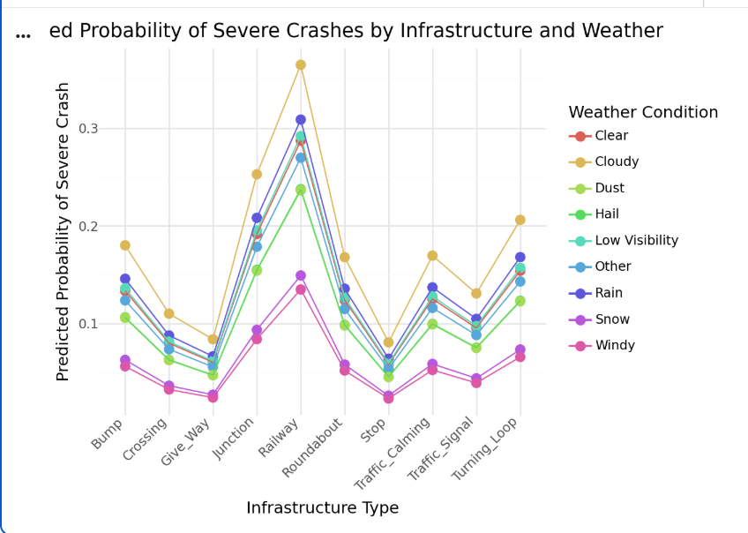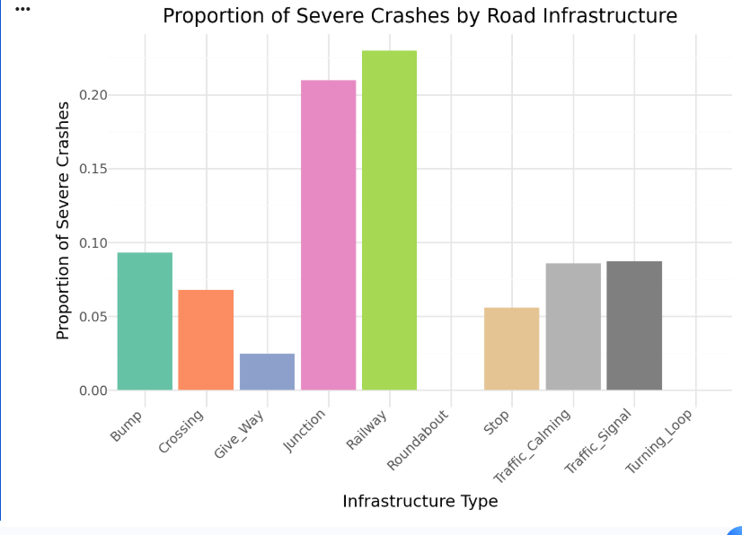

Model (Javier)
In order to address our primary research question, we fit a logistic regression model to predict whether a car accident in California was severe. We chose logistic regression because we decided to convert severity into a binary variable. Severity was initially on a 1-4 scale, but we decided to define a new variable Severe equal to 1 if severity was greater than or equal to 3. 0 if otherwise.
The predictor variables included:
- Weather Conditions (Weather_Group)
- Road Infrastructure Indicators (Bump, Crossing, Give_Way, Junction, Railway, Roundabout, Stop, Traffic_Signal, Traffic_Calming, Turning_Loop)
- Weather measurements (Temperature, Visibility, Wind Speed, Precipitation)
Categorical weather conditions columns were transformed using OneHotEncoder, and the quantitative weather predictors were standardized with StandardScaler. We used ColumnTransformer within a modeling pipeline. To estimate how well this model performs, we used 5-fold cross validation. The model performance was tested using accuracy, which measures the proportion of accidents that were correctly classified as severe or non-severe. We got an average accuracy of .83.
After fitting the logistic regression model, we used it to estimate the predicted probability of severe crashes for different weather and road infrastructure combinations.
To do this, we created a new dataset representing hypothetical crash scenarios. Each row represents a specific weather condition and infrastructure type. For each weather condition, the quantitative variables were set to their average values for that specific weather group in order for the model to evaluate each weather condition under its typical conditions. Through the use of for loops, we assigned each infrastructure to every weather group while keeping the other infrastructure indicators set to 0. This created a set of scenarios representing crashes occurring under each weather condition at each infrastructure type. Then finally, we computed the predicted probability that a crash would be severe for each scenario using the predict_proba() function. The predicted probabilities were stored in the column Predicted_Severity_Risk which represents the probability that an accident is severe or not. This allowed us to compare the predicted probability of severe crashes across different combinations of weather conditions and road infrastructure types.
To address the secondary research question, we fit a logistic regression model to determine which types of road infrastructure are associated with severe car accidents. We used the same binary variable, Severe. We only used the infrastructure variables this time and sampled 500,000 California accidents. After fitting the model, we extracted the coefficients for each infrastructure variable to evaluate how the presence of each type of infrastructure affects the likelihood of an accident being severe.
We chose logistic regression because we thought it’d be best to turn our severity variable into a binary variable. Logistic regression allows us to see interpretable coefficients that allow us to understand how the weather conditions and infrastructure features can be used to explain accident severity risk. We evaluated the first model using accuracy because it measures the proportion of correctly classified accidents and provides a simple way to assess how well the model distinguishes between whether an accident is severe or not.

Results / Implications (Javier)
Primary Question:
The model’s results indicate that crashes occurring with railway infrastructure in the vicinity consistently produce the highest predicted probabilities of severe accidents across multiple weather conditions. For example, under cloudy conditions the predicted probability of a severe crash near a railway crossing is approximately 0.36, compared to lower probabilities for other infrastructure types. Similar patterns appear across several weather conditions, suggesting that the combination of railway infrastructure and adverse weather conditions may create particularly high-risk environments for severe crashes. This suggests that railway crossings may produce high risk areas for severe collisions. This could potentially be due to higher travel speeds, complex traffic interactions, or reduced reaction time near crossing signals.
Secondary Question:
The results of the second model show that railway infrastructure is most strongly associated with severe accidents, having the largest positive coefficient of 0.8. Junctions are second, while stop signs and crossings are negative, suggesting they’re associated with lower severity risk, likely because cars are more controlled here. These findings suggest that railway crossings may represent high-risk environments for severe crashes, while traffic control infrastructure may help reduce accident severity.

Ethics & Limitations (Jackson)
One major ethical concern in regards to our model is that the results of the model could potentially be used to create harmful predictions. For example if our model determines that specific environment or infrastructure characteristics are associated with higher accident severity this could cause a number of potentially harmful outcomes. Insurance companies could use this data as justification to raise premiums or reduce services in areas that have these environmental conditions or types of infrastructure. These areas can also end up being subject to more intense policing and traffic monitoring. All of these things can also result in creating indirect bias by targeting areas that have these kinds of characteristics. This can make it so that communities that are already facing disadvantages end up being further penalized by this kind of data analysis. One limitation of the model is that it doesn’t contain other variables that may also determine severity such as driver info, vehicle type, etc.
.One major limitation is that this data set was compiled using traffic sensors, public accident reports, and various transportation data sources. Because of this reliance accidents that occur in areas with few monitoring systems could very well end up being underreported. This means that the dataset may not be fully representing all accidents equally across the different locations creating potential coverage bias.

